

SUPPLEMENTARY REMARKS TO BEST PRACTICE MANUAL FOR FORENSIC IMAGE AND VIDEO ENHANCEMENT
DOCUMENT TYPE :  Informal Supplement | REF. CODE:  FIVE-BPM-SUP-001 | ISSUE NO:  001 | ISSUE DATE:  XX YY 2015

File name: DRAFT_BPM_FIVE_Supplement_20151208.doc

TITLE
Supplementary Remarks to Best Practice Manual for Forensic Image and Video Enhancement

CONTENT

SUPPLEMENTARY REMARKS TO BEST PRACTICE MANUAL FOR FORENSIC IMAGE AND VIDEO ENHANCEMENT 1
TITLE 1
CONTENT 1
ABBREVIATIONS 1
INTRODUCTION 2
1. AIMS 3
2. SCOPE 4
3. ADDITIONAL DEFINITIONS AND TERMS 4
4. RESOURCES 5
5. METHODS 8
6. VALIDATION AND ESTIMATION OF UNCERTAINTY OF MEASUREMENT 21
7. PROFICIENCY TESTING 22
8. HANDLING ITEMS 22
9. INITIAL EXAMINATION 22
10. PRIORITISATION AND SEQUENCE OF EXAMINATIONS 22
11. RECONSTRUCTION OF EVENTS 22
12. EVALUATION AND INTERPRETATION 22
13. PRESENTATION OF EVIDENCE 22
14. HEALTH AND SAFETY 22
15. ADDITIONAL REFERENCES 22
16. AMENDMENTS AGAINST PREVIOUS VERSION 23

ABBREVIATIONS

ASF Advanced Systems Format (former Advanced Streaming Format)
BPM Best Practice Manual
CCITT Comité Consultatif International Téléphonique et Télégraphique
CCTV Closed Circuit TeleVision
CSI Crime Scene Investigation
DIWG Digital Imaging Working Group (ENFSI)
ENFSI European Network of Forensic Science Institutes
Exif Exchangeable Image File format
FIVE Forensic Image and Video Enhancement
GOP Group of Pictures
HDR High Definition Range
ICC International Color Consortium
ID IDentifying attribute
IEC International Electrotechnical Commission
IFD Image File Directory
IID Independent Identically Distributed
ISO International Standardisation Organisation
IT Information Technology
ITU International Telecommunication Union
JPEG Joint Photographic Expert Group
JFIF JPEG File Interchange Format
MJPEG Motion JPEG
PSF Point Spread Function
QCC Quality and Competence Committee (ENFSI)
QM Quality Management
RGB Red Green Blue
RGBX Red Green Blue Overlay
RIFF Resource Interchange File Format
ROI Region Of Interest
SOP Standard Operating Procedure
SWGIT Scientific Working Group on Imaging Technology (USA)
WMV Windows Media Video
YCbCr, YUV Luminance Y and two colour components

TO-DO LIST:

- For some sections: write more text, i.e., expand summary text/ideas into full text (only if we are sure that BPM-S will be accepted by DIWG/QCC and future use is certain?)
- Replace German screenshots with English text?
- More example images, which/where?
- Collect ownership/IPR info and original source images used within this document and make images available?
- Future extension and updating of the document by DIWG

Some important remaining issues have been highlighted within the text below.

INTRODUCTION

Image enhancement covers a broad range of aims, problems and operations.

Typical aims in forensic image and video examination / evaluation are
- Finding and isolating details of objects and subjects, e.g. features like logos or text
- Identifying objects and people
- Documenting and measuring position, height and orientation of objects
- Documenting sequence of events.

Typical weaknesses of image and video data are
- Bad contrast and colour defects
- High noise level
- Underexposed areas/ overexposed areas
- Motion blur
- Defocus blur
- Compression artefacts
- Low (spatial and/or temporal) resolution, colour subsampling
- Geometric distortion
- Night-vision issues (e.g. infrared images)
- Difficult perception of video because of unsteady movement of camera or object

The image acquisition process restricts the range of possible findings based on the given image data. Some features of the image data are obvious; others may need some effort to be made visible. Forensic Image and Video Enhancement (FIVE) should enable the examiner to make the given range completely usable.
Unfortunately FIVE software does not offer a universal “make better” or “optimize perfectly” button. Instead of one magic button there is a vast repertoire of image operations, described in more detail in the next paragraphs, which have to be combined in the right way to deliver the desired results. Some of the attributes and side effects of operations which constrain the possibilities to build meaningful sequences of operations to complete diverse tasks are described in the following paragraphs.

The intended purpose of the resulting images plays a central role for choosing the optimal enhancement operations and parameters. For example, if images are intended to be used for measurements it is important to guarantee correct aspect ratios and it makes sense to make use of the objective metadata to correct for lens distortions. If only the sequence of events documented in a video is needed, it is much more important that no frames are lost and all frames are ordered along a reliable timeline.

- AIMS

A Best Practice Manual (BPM) aims to provide a framework of procedures, quality principles, training processes and approaches to FIVE. It is an overarching document which sits above detailed standard operating procedures. It is aimed at experts in the field and assumes prior knowledge in the discipline. It is not a standard operating procedure (SOP) and addresses the requirements of the judicial systems in general terms only. It provides high level guidance for the development of a set of SOPs covering the whole process of forensic image and video enhancement.

This Best Practice Manual Supplement (BPM-S) tries to fill the gap between the high level, often rather abstract rules of a BPM formulated according to the guidelines of the Quality and Competence Committee (QCC) of ENFSI (European Network of Forensic Science Institutes), and the much more detailed considerations needed to write SOPs for units performing FIVE. This document aims to give an impression of what could be expected to be a kind of “intersection” or “common technical content” of SOPs found in ENFSI laboratories performing FIVE. At least this document should drive attention to the mentioned topics and initiate (hopefully fruitful) discussions. The supplementary remarks should be useful for everybody interested in FIVE to help them understand, study and implement the practical effects of the BPM.

- SCOPE

  - General

This document supplements the BPM by
- Detailed discussion of field specific problems,
- Exemplary solution descriptions,
- Example images (not yet completed; see [US SWGIT Section 5] and [US SWGIT Section 7] for commented example pictures)
The current version of the supplement concentrates on a more detailed description of the methods used in FIVE (Chapter 5 of BPM).

  - Limitations

The supplementary remarks do not discuss in detail the effects of
- The local juridical system,
- The local quality management system including the used normative framework,
- The more general concepts of digital evidence like general handling of evidential material, chain of custody, contamination issues, secure archiving of digital data etc. as long as there are no image and video specific special effects,
- The subsequent applications of the obtained resulting images, e.g., proper processing of identification or comparison of persons or objects.

- ADDITIONAL DEFINITIONS AND TERMS

The following additional definitions, not mentioned in the FIVE BPM, have been used in this supplement:

Container Format – File format which is used to store media data like video, typical ones are ASF (*.asf,*.wmv), Quicktime (*.mov), MP4 (*.mp4), RIFF (*.avi), Matroska (*.mkv).

Exif - Exchangeable Image File format is a standard for storing metadata. IFD-structures are used to store the items, for more details see [JEIDA Exif 2.3]

FourCC – 32 bit IDs which are man-readable 4 character strings

HDR Image – High definition range image, more than 8 bit are used to store one component of a pixel value

ICC-Profile – system and information used to guarantee as accurate as possible colour reproduction on on different devices i.e., not every device or support (e.g. paper) allows full reproduction of all colours visible by the human eye (device gamut).

JFIF – Standard to store JPEG compressed image data, see [JFIF Description]. The underlying Standard is the JPEG Still Image Data Compression Standard, known as ISO/IEC 10918-1 and [CCITT/ITU Recommendation T.81] and well described in the book of [Pennebaker & Mitchell]

Pixel Format – bit depth and colour scheme

Raw Image – Pixel data without header or image of a digital camera stored in its native format
Raw Video stream – Video data delivered/needed by a codec

- RESOURCES

4.1 Personnel

4.2 Equipment

4.2.1 Influence of settings
Systems used for video processing need special care. Some Viewers carry and use their own codec libraries; others rely on the general accessible installed codecs. The behaviour of a viewer with respect to these possibilities should be known or investigated by the examiner when using it. The state of the installed codec database may change in an unforeseen way if new codecs are installed (which might occur transparently) and the de-install operation may not be an undo operation at all. A secure way to overcome codec incompatibilities is to start with a standardized system state and install exactly what is needed for a specific case.
Another source of influence may be found in the settings of the graphic system which often contains hardware support for video display. These settings should be set to a well-defined state, especially if they have an impact on things like data value clipping or acceptance of software settings as in the following example.

Example:
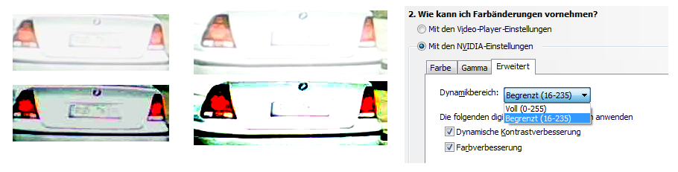
Different views of frames of the same *.AVI Video (MJPG) with VLC, depending on video settings. The settings of the player software itself are the same, but the video settings of the graphics card firmware have been changed via the system driver and control component (a part is shown above, German user interface). On the left, some information is still present in the images, on the right; clipping has erased nearly all of the number plate content (original above, contrast enhanced version underneath).

Another example taken from the S-FIVE Project Bonus CE [[insert link to “solution/discussion” document]] shows different results of single frame extraction from the same video file delivered by different tools using different settings for the colour conversion from YCbCr to RGB.

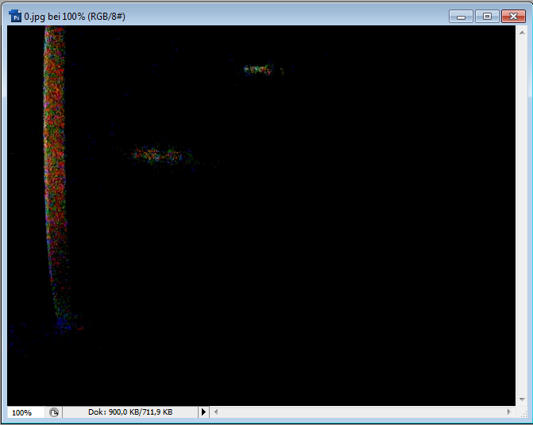
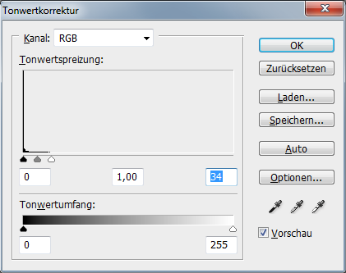 | Most of the image content is lost, caused by an internal clipping operation. In the image histogram the peak at zero indicates the clipping disaster
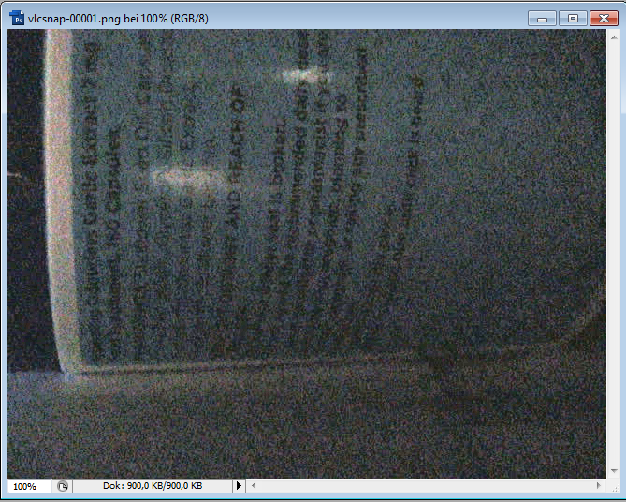
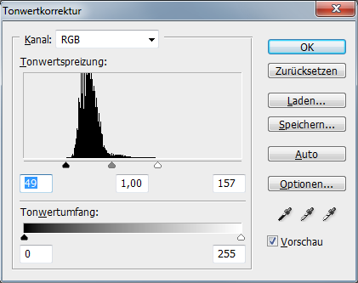 | Better settings (here: on program level) allow optimal usage of the content of the video frame.

4.2.2 Influence of image data formats on image quality
Digital images are characterized by height and width (measured in number of pixels) and pixel format (bit depth and colour scheme, e.g. 32 bit RGBX (Red Green Blue Overlay)). To be precise we have to distinguish between the sampling methods the storage format allows and the real resolution of the image data, which might be lower, e.g. induced by lossy compression. Changing pixel format or switching between disk storage and internal formats in memory may have severe influence on precision of image data and overall picture quality. An extreme example are colour images stored internally as full resolution RGB, each channel as 32 bit float or 64 bit double, and stored on disk as YCbCr (Luminance Y and two colour components) 4:2:0 JPEG (Joint Photographic Expert Group) (8 bit precision unsigned integer RGB in/out, colour channel subsampling in both directions and quantization to achieve even more compression). Especially if sequences of operations are applied on (sequences of) images these issues may be particularly important. Hardware characteristics like amount of memory equipment and software characteristics like internal image buffer bit depth and image/video file format support have to be taken into account to provide sufficiently equipped systems and to develop optimal processing chains.

4.3 Reference materials

Reference images and videos play a central role in the validation process for FIVE software. An ideal collection of reference materials is
- Small enough to be processed in appropriate time, but
- Broad enough to cover the important and the difficult cases and
- Equipped with a collection of the corresponding correct results (“ground truth”) which can be compared with current test results (hopefully automatically, see Section 6. Validation)

4.4 Accommodation and environmental conditions

4.5 Materials and Reagents

- METHODS

5.1 Peer Review

5.2 Analysis, Compatibility and Consistency checks

5.2.1 Viewing capability
If there are file formats or codecs which cannot be handled properly, additional software has to be obtained (e.g. from the customer or an internet site), installed and tested. For many proprietary formats CCTV (Closed Circuit TeleVision) databases like [London Metropolitan Police SMART] give hints about suitable viewer software. More information about tools can be found on the S-FIVE website (as long as it is available) and the new ENFSI DIWG website (hopefully, as soon as operational) and elsewhere on the internet (as long as it is allowed to search for it openly). Asking the other DIWG members via mailing list is another good possibility to find information and get support (although similar security issues may apply).

If the container format is a well-known format like *.AVI but the actual data codecs are unknown, the ID of the codec (FourCC, Four-Character Code) can be searched on the internet (e.g. [fourcc.org]) and a suitable codec installed on the system or a viewer with suitable on board codecs can be chosen.

Reverse engineering of the data stream may lead to a deeper insight into the internal structure of the data and show ways to make it playable by at least one of the available viewers through minimal modifications, e.g. by changing the file name extension or deleting additional non-standard header information, or extracting single frames, e.g. in case of Motion JPEG (MJPEG) variants. At that point the examiner should sort out obviously useless data, concentrate on the rest and try to find well suited software to handle the remaining data.

Today’s standard video formats are rather complex and the usually used parameters might be a small part of the formally correct ones. There may be different possibilities to include the same information and the strategies of viewer software to handle missing, unusual, wrong or contradicting parameters are numerous. Using more than one viewer software for playing a video is encouraged, especially if unexpected effects show up.

5.2.2 Picture quality

5.2.2.1 Size and aspect ratio
The first step that should always be carried out is the verification if frames are shown in the correct size and aspect ratio. If the display size can be modified by resizing the viewer window it is clear that interpolation is used. One should thus check if this is optional and which alternative settings are offered. The frame sizes of all extraction methods should be compared for being identical (and coinciding with the results of reverse engineering, if already done).
As far as image content allows it, subsequent checks of the correctness of the aspect ratio should be performed, especially if there are hints like aspect ratio modifications in the viewer, unusual sizes or just a feeling of suspicion looking at the images.
One of the most frequent reasons for problems with image display and processing is interlacing: The original data contains video fields which can be processed for display purposes in various ways which may be not optimal for further processing. Often viewers try to correct the aspect ratio by using some simple interpolation method and fields can be skipped or reordered (see 5.2.3.1. for details).
In some cases viewers apply some clipping to get an aspired display window size. This should be checked at least if important parts of image content lay near or on the borders.

5.2.2.2 Decoding quality
Due to differences in decoder implementations, parameter settings or usage, there still might be technical problems to visualize files with optimal quality. For example, in rare cases the chosen codecs may deliver inferior quality pictures compared to the data that is present in the data stream. It may be difficult to recognize this problem if the effects are not obvious and the decoded video quality corresponds “sufficiently” to the expectations. A cross-check with an alternative viewer which uses another (potentially better suited) codec, or a data carving or reverse engineering of the files could help, but this may to be too costly to be done routinely. Instructive examples of colour conversion problems have been given in 4.2.1 already.

5.2.2.3 Metadata and overlays
If metadata like camera ID or date and time is shown in the frames it has to be checked if this is original encoded image content, or if this information is added (overlaid) by the viewer (after decoding the image data). If it is overlay information, it may be possible to change the position or switch the visualisation of this information on and off. Changing these settings can be done according to the (Client’s) needs, e.g., if interesting image content is covered by the overlay information. If frames without overlay are exported the metadata info may be conserved by another method, depending on the viewer’s possibilities (e.g. file naming, adding metadata elements or acquiring additional screen shots). As far as possible automated methods should be used, because manual input of date/time is error prone. In all cases where metadata is not stored together with the video data but computed by the viewer or read from elsewhere the correct match between frames and metadata should be checked. In some cases it may be requested by or of interest to the Client to add in data and time information. It should be noted that this introduces an additional software dependency which should be properly tested, documented and reported on, etc.
Similar remarks can be made for adding other overlays such annotations or “highlights” to certain objects or regions in images and videos.
In all cases the image material without overlay information should be archived, or the original image input image material together with sufficient information about the procedure used to obtain (and reproduce) any annotated result should remain available.

5.2.3 Selection capability
The next step of the check should try to assure that all frames of the video data can be visualized and/or selected with the methods the viewer or FIVE software provides to the user. Depending on the positioning pointers provided by the container format, the Group of Pictures (GOP) or frame/field structure of the data, the codec implementation and the frame caching capabilities of the viewer or FIVE software, the setting of positions for single frame display or selection (stepping forward/backward) and start of playing forward/backward operations may vary in a wide range. The behaviour of any used tools should be studied, and if possible or deemed necessary (risk analysis) cross-checked with other tools, before the final selection of frames is performed. The use of software which is able to provide exact frame numbers should be preferred. It should also be noted that the behaviour of any software tools may change depending on the input data that is provided, i.e., a tool may correctly show all frames and/or frame numbers for one file format, but not do so for another file format or codec. The process of exporting a sequence of consecutive frames should always work properly.

5.2.3.1 Interlacing
If a viewer software has to be used to extract stills from an interlaced video and store it in a suitable format there are three possibilities to create stills for display and storage:
- store the complete frame, even if it contains very different fields; the FIVE software has optimal information to de-interlace and interpolate; may be difficult to combine with a display mode where the fields can be used to evaluate the image content for selection, frame image may be hard to interpret if the fields are very different. If there is no motion (e.g. no zigzag instead of straight vertical edges) it can be an option to use the whole frame for further processing and take advantage of the full resolution.
- store interpolated fields; has the disadvantage that a built in interpolation is used which might deliver low quality results; if at least one field of the result is identical with the original field, a FIVE software should be able to extract it and apply another interpolation method (as long as the right field is chosen as basis). Often the rows are duplicated, that makes processing easy but information about field1 or field2 is lost. Best for display purposes.
- store fields; info about field1 or field2 may be lost (quality of fields may be different, correct numbering must be preserved) and aspect ratio is wrong, but most economical storage amount

5.2.3.2 Time multiplex
Time multiplexed video streams from several cameras are difficult to evaluate without a camera selection function. The camera id may be coded in the metadata or somewhere in the image, or the frames may have to be classified according to their image content. If FIVE software is unable to do the camera selection properly, the camera streams of interest have to be extracted and stored separately by a specialised viewer. Details about the export format are given in 5.2.4. Special care has to be taken to retain the frame order information and to avoid loss of frames, especially if there is a (pseudo) random order of camera sources and the camera classification is carried out based on image content instead of camera id. It might be useful to perform a complete decomposition of the video and check that all frames are classified and all relevant streams seem to be uniform.
Motion triggered camera recording may also require special demultiplexing steps to be carried out.

5.2.4 Export capability
If there is a data format which is not compatible with the FIVE software which will be used to process the image material, the examiner has to check whether the viewer supports the export features needed to extract the frames of interest in a format that can be used for FIVE.

If an export format uses lossy compression, it should be avoided if it is not assured that no recoding is performed. To prove this it is not sufficient to compare only the codec type, but all details of coding and ideally at least one frame data example. Uncompressed and lossless compressed formats are a safe alternative, but may lead to a severe increase of storage demands.

Recoding/Transcoding into another video format to make it readable for a FIVE tool should be avoided, because of a possible quality loss, depending on the different codecs. Switching to another container format may be acceptable, if it has no influence on image quality, but it should be noted that metadata like time stamps may get lost and the display rate may become distorted (which may lead to misinterpretation of actions). Easiest access to the frames of a video is via decomposition and storage of each frame as a single image file (uncompressed or with lossless compression). This may also reduce the risk of FIVE tools not properly decoding the original data (e.g., due to implementation differences, coding issues, etc.).

Screen-grabbing of the player output should be considered as an alternative only if image or video export delivers poor results compared with player display content. Disadvantages are the additional coding step (which should not lead to loss of quality) and the independent frame rate which should prevent frame drops when grabbing continually in play-mode [US SWGIT Section 24]. A proper strategy for de-duplicating grabbed frames may also be needed.
From the opposite point of view screen-grabbing could be useful to determine if a certain viewer tool also properly exports the displayed frames to another format or frame-by-frame individual image files.

5.2.5 Basic consistency
Having access to the images gives the possibility to perform more intensive preview checks to verify the result of the assessment process: The images are correctly selected and seem to be original. In general the tendency to perform additional checks should grow with:
- Lack of trust in the provenance of the data, e.g. bad experiences with this kind of source.
- Observation of unexpected / unusual features (deviation from expectation, e.g. MJPEG frames with notches in the histogram, different noise levels on similar image content).
- Significance of the authenticity for the aim of the enhancement, expected risk that authenticity might be questioned.
It is not necessary to do all the following checks in the preview state, but the examination should be restarted whenever e.g. an inconsistency is encountered.
Typical preview inspection methods are (list is not exhaustive!):
- histogram analysis (look for notches to detect traces of pre-processing, check range to estimate enhancement potential)
- noise analysis (comparison of macro and micro structure of the image, amount and 2D and/or temporal variability of compression artefacts, recompression test)
- check edges of objects for interlace effects and interpolation traces
- check consistency of parameters in metadata of digital video files
- ….
All upcoming doubts and questions have to be resolved, e.g. in discussion with the customer, before data and description are supposed to be consistent and this step is finished successfully. If there are still open questions remaining, it is necessary to start a more intensive examination of authentication issues, which is beyond the scope of this document.

5.3 Selection

5.3.1 Inter-tool compatibility
It is sensible to collect copies of all selected frames in a directory to be able to process these selected images with other tools if required.

5.4 Single Image Processing

5.4.1 Simple image operations
Functions like cropping, flipping and rotation (in 90 degree steps!) should be possible without any quality loss, as long as the implementation is done properly. Even these simple operations may lead to problems, especially if rows and columns are exchanged, e.g., Filters like De-interlace only work on rows, not on columns. Some operations may require the image width in pixels to be of an even number, whereas the height has no such restriction.
- Height and Width may have different maximum values (in certain tools), e.g., max HD video size, and simple operations may create image sizes which cannot be handled properly by other tools (e.g., decoding video with uncommon sizes after cropping)
Flipping and rotation are invertible operations and can be applied and visually reversed at any time. Cropping is not invertible: If more image content is needed in the end, stepping back to the original is necessary and any progress made by application of other operations is lost!

Processing of JPEG images (based on a grid of 8x8, 8x16 or 16x16 blocks) offers two alternatives:
- Working on the decompressed internal image format will allow any of the simple operations but may also have an impact on the positioning of the grid structure (e.g., when the image dimensions are not a multiple of the size of coding grid blocks), and may thus make application of further enhancement filters like de-blocking more complicated. If the image has to be stored as JPEG again recoding is necessary, even if the same quantization tables (of the original JPEG file) are used. Normally, image processing tools compute their own tables (e.g. using a fixed base table and a quality measure) to create new JPEG files.
- Use of specialized routines to compute new JPEG data without recoding may depend on restrictions like parameters being divisible by 8 (or even 16) and may lead to losses of image content near borders in case of non-compliance.

5.4.2 Format conversion
Conversion to another pixel format (sometimes in conjunction with file format conversion) often takes place without special user interaction and depends on the implementation and setting details of the image processing tool. Visualization on a standard screen needs image data in 3x8bit RGB format normally. Higher precision images (e.g. HDR (High Definition Range) Images or RAW images) have to be converted somehow to this format (see 5.4.3). The effects of internal conversion procedures (on e.g. colour calibrated systems) normally do not show up during image processing, but may become visible if histograms of resulting images are examined carefully (see example below).
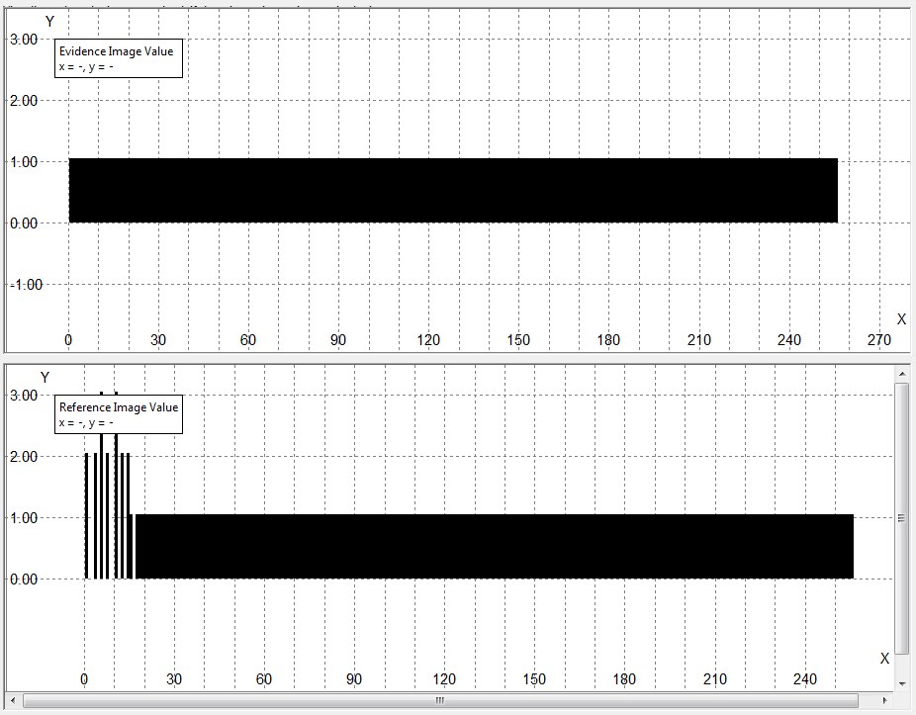
Comparison of histogram of a grey wedge before and after a colour space conversion, the histogram below shows notches on the left side.

A common reason to convert images explicitly is to strip off colour (which is often stronger compressed and shows more artefacts) and use luminance only to form a one channel grey level image. In colour spaces like YUV it is easy to just pick up the luminance component Y, in case of RGB a standard matrix row like
Y=int(0.299*R+0.587*G+0.114*B) or similar
should be used, instead of simply choosing one of the colour channels. This operation is obviously not invertible and the exact result may depend on a lot of factors like type of calculation (float or integer), precision of weighting factors, bit depth of components etc.
Looking at single colour channels (as grey level image) may be advantageous if the signal to noise ratio is different in each or some of these single channels.
Lossless conversion to another format should not change the pixel values and therefore should not alter results of processing. Format conversion might be necessary to make image data compatible with the input capabilities of image processing software which has a restricted range of input formats. There are some special cases where metadata may help to get better results, e.g., EXIF (Exchangeable Image File format) data may deliver precise information about the used optics, or JPEG quantization tables may help a de-blocking tool to find the best parameters.

5.4.3 Lookup table operations
Overall contrast/brightness operations modify the pixel values by creating one global or a locally varying lookup table. They are indispensable if the source image format has a larger range than the target image format, e.g. 12 bit RAW image written as normal 8 bit JPEG. In that case, if the histogram of the source image is fully populated the operation cannot be inverted and the shape of the lookup table decides which parts of the contrast are ignored and which parts are preserved or even stretched.
Global lookup tables which increase contrast in one image area tend to create loss somewhere else, often in light and/or dark areas of the image. Local contrast enhancement operations on the other hand eliminate part of the global brightness distribution and can produce extreme contrast stretching in nearly uniform areas.
Examples of overall operations are:
- Settings luminance (brightness) and contrast (contrast)
- Convert positive to negative (positive to negative inversion)
- Convert to black and white (conversion to grayscale)
- Balances colour (white balance)
- Colour Correction (colour balancing / colour correction)
- Gamma adjustment
Stretched contrast regions correspond to barely populated histogram areas. Additionally, histogram algorithms generally reduce the number of different possible pixel values as the stretched or recomputed pixel values need to be rounded to discrete values again (0-255).

Contrast enhancement operations are commonly used for selection of suitable images and optimization of end results, but may not be ideal as input to e.g. restoration operations which depend on a special image formation model. Other filters can profit from preceding contrast stretching: the results of a combination like stretching/smoothing are better than smoothing /stretching, if the intermediate result of smoothing has to be rounded before stretching is done.

5.4.4 Filtering
Filtering (linear spatial, convolution) is a class of operations which can perform different tasks, depending on the kernel. Typical kernel types are low-pass (smoothing, e.g. with binominal kernel), high-pass (sharpening) or band pass filters, edge enhancement. The process of filtering seems simple, but the design of filters can be complex depending on the task, e.g. finding estimates for inverse filter functions for common image defects. Most image enhancement tools provide a wide range of filter operations like sharpen, unsharp mask, diverse blurring and low-pass filters and derivative filters. Filters deliver correct results in the inner area of an image only because of the kernel extent; the results near the border depend on implementation details. Filtering might deliver a slightly shifted image, depending on the designated centre point of the kernel. There should be no shift if the designated centre point is in the middle of a kernel with odd dimensions. Convolution tends to become time consuming if image and kernel sizes grow. For separable kernels like the binominal smoothing successive 1D convolutions offer a faster solution. Another possibility is to switch into the Fourier domain and use multiplication instead of convolution.
Linear spatial (FIR) filters with invariant kernel are not the only class of filters used in image enhancement. Many filter functions use some kind of adaptation to control the impact of the filter and get a better ratio between wanted (e.g. elimination of noisy pixel values) and unwanted effects (blurring of edges):
- Some noise reduction filters may alter pixel values only where deviation is above a given limit or exclude outliers from the local mean estimation
- Other noise reduction filters may alter the kernel size depending on a local noise measure or put the emphasis on smoothing along a local edge
- Diffusion based filters try to reduce unwanted image elements stepwise or iteratively, using a completely different mathematical basis than convolution filters.
It is important that the control is done by image metrics, not by manual “painting” using a pointing device which might be seen as manipulation.

In the frequency domain (obtained by applying e.g., a Fourier transform), filters which may need some manual editing can be used to eliminate or reduce periodic patterns disturbing the image content. These peak elimination functions visualize the power spectrum of the image and should show bright peaks corresponding to the periodic pattern which can be suppressed, controlled by an automatic peak detector or a manual interactive input device. Results of this type should be accompanied by visualizations of the original and the processed power spectrum of the image. Additional documentation might be provided by computing and presenting the difference between the original image and the filtered image. This difference image should then contain the eliminated periodic pattern and nothing else.

Other examples of non-linear filtering methods are rank-based filters like median filter. These filters do not create new pixel values but choose one of the locally available values, in contrast to the convolution filters. Median filters are less sensitive to outliers than linear filters, but often increase the risk of producing false contours.

Filtering of colour images normally is done by application of identical filters to all channels of the image. In special cases it could be advantageous to filter in a suitable colour space and account for e.g. different compression factors of the channels, but that is seldom done in reality. More important are linear combinations of the colour channels, which can be used to make colour features better visible. Prior to such operations the registration of the colour channels should be checked at the sharp edges found in the image. Additionally the possible presence of chromatic aberration has to be verified and if needed corrected (see 5.4.6 and example below).

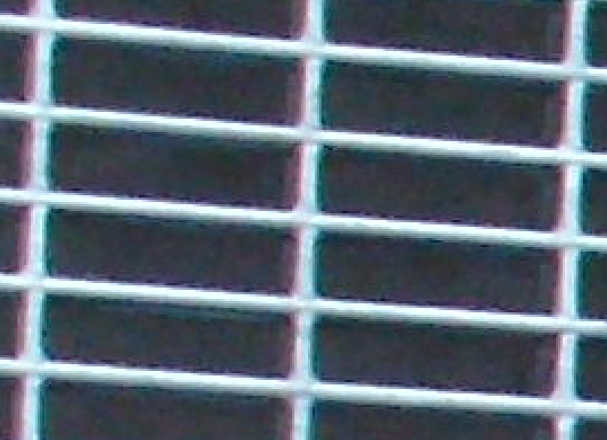
Example image shows different colours on the left and the right side of the grid.

5.4.5 Boundary effects
If an operation is applied to the whole image there may be boundary effects. Different image processing tools may handle boundary effects in different ways; they may:
- Deliver processed values in the middle and the original pixel values along the boundary (not necessarily easy to distinguish)
- Deliver processed values everywhere, by modifying the algorithm somehow near the boundary (operation may have different impact near the boundary)
- Deliver a smaller result without the boundary pixels
- Replicate or extend the original values near the boundary to extend the source image and clip back to the original image size after applying an unmodified algorithm to the extended image

The forensic expert should be aware of these boundary effects and should make a suitable remark whenever parts near the boundary may play a role. Generally speaking any cropping performed before the application of operations with large kernels and strong boundary effects should be minimized. This will help to eliminate the use of areas incompatible with the operation and introduction of artefacts due to boundary effects.

5.4.6 Image warping and interpolation
Image warping and interpolation are very important classes of operations, because they are used quite often and the correct choice of the algorithm and the parameters may have strong influence on the quality of the result. Reasons for warping / interpolation are numerous:
- Resizing, especially enlarging details
- lens distortion correction
- perspective distortion correction
- De-interlacing (disengagement)
- Registration of different frames or channels
- …
The methods to be used are even more numerous, reaching from simple nearest neighbour duplication to bi-cubic interpolation and even more sophisticated model-based methods. Some advanced methods like model-based ones enlarge images of scenes by stretching the background without touching prominent elements. These are not useful in typical forensic applications and should not be used, but should be known and detectable.
Forensic experts should be aware and possibly point out that resizing may create a false sense of possibilities to enhance the image (or may even result in incorrectly deduced information and interpretation of the image). In particular this may also be problematic because resized images are often interpolated, which may create a subjectively pleasing smooth image. This situation can be remedied by also providing the image region at its original size, or, by providing a second enlargement using only nearest neighbour interpolation (which creates pixelated blocky image illustrating the real information density embedded in the image data).

For example (reporting example):
DO NOT DO THIS

Figure x: image enhancement result for picture XYZ
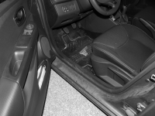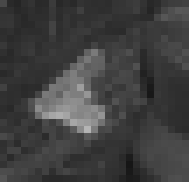
Figure X: zoom-in result for Picture XYZ: (left): original image with indication of the zoom-in area; (middle): 800% zoom-in using bicubic interpolation; (right): 800% zoom-in at the raw pixel level (pixel replication). Interpretation of this image should mainly consider the image on the right as this best demonstrates the actual amount of pixel information available in the image; see main report text and technical report appendix for details.

De-interlacing is an important operation needed for processing interlaced video. Different interpolation methods can be used to correct the aspect ratio and add the missing rows to field images. Different Interpolation methods might also produce a small vertical offset between odd and even fields. Correct registration and ordering of successive fields and frames should be checked afterwards.
It is important to check carefully for prior operations on interlaced footage, which might influence the chance for successful de-interlacing: Interpolation can change the row structure, filtering can mix the content of rows of different fields, but any look up table operation does no harm. Performing de-interlace first should be standard.
Operations like single pixel noise cleaning (e.g. removal of salt and pepper noise) can be accomplished more efficiently prior to the interpolation step which causes propagation of noise into the neighbouring pixels. Note that this leads to a stronger filter effect in vertical direction in the end: a 3x3-kernel used on a field correlates to a 3x5-kernel used after the interpolation step.

Enlarging ROIs (regions of interest) is the most frequently asked image enhancement (and quite easy, fast and successful as everybody knows who ever watched CSI on television). Enlarging part of a single digital image cannot really present more information than the original image, even if the method is called super-resolution (See Section 5.5.4 for a more detailed discussion on multi-frame super-resolution).But there might be technical reasons to compute a zoomed version of an image: to be less depending on built-in zoom capabilities or to circumvent limitations of software like limited kernel sizes or lack of sub-pixel registration precision. There is no algorithm which is optimal for all applications and a detailed description of algorithms, their advantages and disadvantages, is out of the scope of this document.
A pixel replication (nearest neighbour interpolation) produces a blocky visual impression which is great to document the basic image quality and avoid any smoothing effect. Bi-cubic interpolation produces a nice smooth image and is supported by most image processing software. More advanced algorithms that use (and depend on) self-similarity or large databases of known picture elements are able to produce nice looking pictures but should not be used in forensic applications without evaluating the necessary grounding facts in the given scenario.

5.4.7 Image restoration
Image restoration (blur removal, e.g. blind de-convolution) tries to reduce degradation effects and get a better visual impression of the original view the picture should have shown. There are two classes of restoration methods: Most of the methods need some a priori info about the Point Spread Function (PSF) or blur function, ideally an (close approximation of the) inverse, and parameters like noise level given to calculate an estimate of the original image. Typical blur functions belong to the motion, gauss or defocus blur families, controlled by one or several parameters which have to be chosen manually or by measurement. The blind de-convolution methods, on the other hand, try to estimate the blur function, and need much less previous knowledge about the blurring process.
Restoration methods can be divided into iterative and direct methods. Direct methods compute the end result in one single step, iterative methods try to improve the image successively and have to be stopped if the process has become stationary or the results get worse.
The main problems of restoration are
- The bad mathematical condition of the task: it is an inverse problem and can’t be resolved without additional stabilization/regularisation. In fact the regularization terms describe somehow, what a good result should look like. Forensic software has to avoid too restrictive regularization rules (image content models) and has to be strictly data driven.
- Lack of information about the real point spread function: theory delivers some families of ideal kernels, but real defects are often not well approximated by these kernels. With some luck it is possible to extract estimates of the point spread function from suitable image structures (tiny bright stars on a dark sky are ideal candidates, unfortunately not too common in forensic imaging). Most restoration methods are based on models which assume a constant (per image or ROI) Point Spread Function (PSF), but real motion, e.g. of a person in foreground, with stationary background, shows different movements and therefor different amounts of motion blur, varying over time and place.
- Noise (which is a synonym for all deviations between an ideal filtered image and a real one). Noise can be seen as a superposition of random or correlated effects from different sources, with different statistical parameters. Most theoretical work assumes independent identically distributed (iid) additive Gaussian noise. In practice we often find severe compression artefacts which are not well modelled by a Gaussian distribution. A good method to reduce the bad influence of noise on restoration results is to reduce the noise level by averaging numerous versions of the same image content with independent noise (if available). Averaging n versions lowers the level of additive noise by factor sqrt(n) (see 5.5). Interestingly, some forms of noise such as PRNU camera sensor induced noise can be used to authenticate images or link them with each other or their source cameras, but this falls outside the scope of this document.
If more than one type of blur is found in an image, e.g. motion and defocus blur, it may be disadvantageous to try to correct the different blur types in successive steps. The first restoration process might introduce artefacts which complicate further restoration operations. A better solution (if available) might be to define one or more joined kernels to restore both blur types in one step (depending on the position in the image, e.g. if camera motion resulted in spatially varying motion blur).

5.5 Image Sequence Processing

5.5.1 Motion analysis
Motion analysis is the foundation required for all advanced image sequence operations. Most of the reliable methods are based on the matching of image features in subsequent images. Calculation of displacement vectors between images connects the same object features in different frames of a sequence, and delivers an estimate for the relative motion of that feature in each picture. Motion blur can be estimated by local displacements, if the relation between frame rate and duration of exposure is known.
It is clear that 3D effects, lighting and (de)occlusion, image border effects and non-rigid objects may impede a perfect matching. An ideal matching algorithm should be able to deliver a quality measure for each match and detect a failure, but in real life those abilities are seldom found. Manual corrections and elimination of problematic images can help to end up with a better registration. The choice of well-defined and stable features is crucial to the success of the analysis. Features at the border of moving objects might lead to problems with changing background, for features of the background it is important to avoid frequent occlusion. Especially if content structure is sparse, weak and/or blurred, some manual support may be necessary to find the correct displacements.
Advanced methods should be able to deliver sub-pixel precision displacements, simpler ones integer pixel values. Without sub-pixel accuracy, enlarging before registration enables to obtain better displacement precision, at the cost of larger amount of data. The chosen interpolation method to enlarge the images may influence the matching result.
For stabilization tasks the motion analysis can be done on successive frames, which promises most similar features and therefore best matching quality. For registration purposes the use of one reference image is strongly encouraged. Results of adjoining frames can be used to minimize the search space without losses.
If more than one feature per object is used more detailed motion parameters can be computed. A popular model for the motion of a (rigid) object is the affine one, offering up to 6 degrees of freedom. Degrees of freedom which are not needed should be set fix. Three independent features are sufficient to define the full set of model parameters; if there are more, a simple optimisation can find the best match or identify outliers. Such models can deliver the dense displacement fields needed for registration purposes. It should be taken into account that these models may not reflect perfectly the behaviour of the objects all the time, especially if 3D effects play an important role.
Motion analysis should concentrate on the ROI parts of the images, e.g. background or one moving object instead of the whole image.

5.5.2 Stabilization and Registration
Stabilization is a process to eliminate parts of the motion vector and to smooth the motion of an object in an image sequence. In its simplest form an object point in a reference image is chosen and all other frames containing this feature point are shifted to the position in the reference image. The transform can also enfold more sophisticated components like zoom and rotation and be based on more than one point. The aim is to eliminate motion components like high frequency jitter to make it easier for a human observer to track the object/scene.
Registration tries to warp the object pixels exactly to their corresponding positions in the reference image, e.g. as pre-processing for fusion operations. The result of a registration process should be always checked before used for fusion, at least by watching the transformed sequence, e.g. in a loop.
In case of integer global shift motion field values no interpolation is necessary, but precision is low. In case of sub-pixel accuracy or more complex motion fields, interpolation is needed and accompanied by a certain degree of smoothing. Larger shifts lead to black borders in the shifted images and may affect the visual impression of a human observer. Reduction to a smaller ROI is the easiest way to suppress that effect. Extrapolation or use of a background collage to complete the shifted images may enhance the visual impression of the running image sequence but has to be declared carefully, single frames of that type should not be used without clear indication what is background collage and what belongs to the current frame.

5.5.3 Image fusion
Image Fusion is an important tool to reduce noise with minimal loss of spatial resolution. In case of additive noise averaging of well registered frames is a simple and effective method to decrease noise level.
In many cases involving modern compression methods the quality of frames and smaller parts of the frames varies in a wide range. That raises the question, whether an equally weighted average of all frames is the best possible solution. As long as bad quality means very low contrast these images do no harm to the result and can be hold in the stack, but if bad parts of images contain e.g. compression artefacts they would aggravate the result and should be excluded from the fusion.
In order to examine which frames to use, the type information of each frame may be investigated (e.g., was I, P, or B coding used), or frame differences may be computed by subtracting frames that are adjacent in the temporal domain. Modern fusion algorithms try to integrate those aspects into their optimisation strategies. –Similar arguments are applicable to registration defects. Simple Algorithms do some kind of local registration and averaging in time. For optimal results, it is useful to select a good reference image, select the best quality similar frames, test whether they can be registered well to the reference image and use the best ones for fusion.
A background collage made up by stitching and stacking the background parts of all images may be useful to illustrate the complete scene without any moving objects.

5.5.4 Super-resolution
The implementations of the concept of super-resolution may cover sub-pixel accurate registration, de-blurring, motion estimation, frame fusion or averaging, and interpolation aspects. The algorithms try to compute a higher resolution version of an image sequence, usually using a given number of successive frames. Typical zoom factors are in the range 2 – 4. Without detailed knowledge about the scene the dominant factor of the underlying image model has to be smoothness, which often leads to nice looking results without additional reliable details.
If there are new details coming up it might be difficult to explain how they developed from the original frames. The limitation to successive frames may lead to a smaller number of well registered images than necessary, but the combined optimization of registration and restoration of (motion) blurring offers advances, compared with other methods. Typical parameters are smoothness, blur, number of frames used, and number of iterations.

5.6 Documentation

5.6.1 Logging
Log files are necessary to be able to reproduce and thus verify the results of image processing operations. The quality/particularity of automatically produced log files depends on the used tools. These logs may be encrypted and may offer replay functionality or not. They have to be named in an appropriate way and safely stored, together with all relating images. It may be necessary to collect data from different directories, e.g. if some logging data is stored in user specific areas instead of the case specific areas.
If necessary the automatically delivered log files of the FIVE software should be accompanied by an additional manual log to deliver all information necessary for a rebuild of the (intermediate and end) results. The log has to be detailed enough to allow the production of result images (at least on the same device) that are very similar/equivalent to the original ones. Perfect identity of pixel values should be possible if all parameters were logged at full precision (perfect replay capability).

5.6.2 Configuration differences
It should be noted that a 100 per cent description of all parts of a software/hardware configuration, that may influence results of an image enhancement process, is difficult to get. Name and exact version of image processing software are the basic information, but much less obvious things like computer hardware, operating system and installed codecs, libraries or plug-Ins may have some influence on results, too. That leads to the possibility, that a retry delivers deviating results on other devices or the same device in a later state, even if the configuration seems to be very similar, the log is complete and the processing is repeated correctly.

5.6.3 Configuration stabilisation
One aspect of reproducibility is to ensure consistency of documentation and results. In order to successfully replicate results with high precision and certainty, the processing documented in the log should be repeated using an (almost) identical system configuration. One method to set up specific configurations later on is to start always with a fixed configuration and add exactly the components which are necessary to process the data at hand. That method reduces the amount of storage to the (stable) basic system which is voluminous but the same for many cases and the case specific modifications (if any) which should be easier to describe and store.
A risk analysis evaluating these issues (5.6.2 and 5.6.3) should be carried out and documented with the QM framework.

5.6.4 Test alternatives
A second aspect of reproducibility is the chance to compare the results of other functions or parameter settings with the original ones at each of the processing steps to verify a correct choice of processing chain.

5.6.5 Implementation check
Another aspect of reproducibility is to check the correct implementation of the operations described in the log. A human readable version of the log file should enable an experienced examiner to get similar results using another equivalent system and repeating equivalent processing steps. If similarity does not reach the expected level an evaluation of the affected software functions is necessary.

5.6.6 Presentation issues
FIVE results can be stored in formats which are widely used and in a manner which delivers a rich choice for appropriate viewers. Usage of more sophisticated elements like ICC colour profiles should be accompanied by hints that the viewers for that data should be able to interpret such elements appropriately. Otherwise there could be an appreciable difference of views on the data, depending on different skills of the viewer software, e.g. correct usage of ICC information or ignoring it.
Especially if the original video footage seems to carry inconsistent parameters (compare 5.2.1) it has to be assured that the results are perfectly consistent and shown in the same way by all viewers in use. Differences of the outputs of different viewers applied to the original video footage should be described and the preferred ones should be given.
When reporting or presenting results, FIVE experts should consider that modern IT systems may be leaking information (such as file path information, author and document history, reviewing, commenting and other information). It should be noted that different versions of text processing tools and document format conversion tools may or may not properly strip or add such meta-data.

- VALIDATION AND ESTIMATION OF UNCERTAINTY OF MEASUREMENT

Comparison and assessment of FIVE results is not straightforward: images are more complex than single values. If all parameters are fixed, no randomized inputs are used and the metadata is the same, then the results of two different versions of a software product might be identical (revalidation). This can be checked easily e.g. by computing hash values.
If only some metadata included in the resulting files is different, the pixel content can still be checked for identity.
If another implementation of the same algorithm is tested details like boundary or rounding effects may impede identical results but can still be checked.
Otherwise image content cannot be expected identical and some kind of similarity or quality measure has to be used for comparison. The range of possible useful measures is too wide to give an exhaustive list and is also related to the FIVE operation used and the following evaluative steps by the customers.

- PROFICIENCY TESTING

- HANDLING ITEMS

8.1 At the scene

8.2 In the laboratory

8.2.1 If processed (e.g. contrast enhanced) versions of images are used to select the useful ones, care needs to be taken that the corresponding originals are stored (or at least documented) and can be used for further processing.

8.2.2 For very large primary video files it is sufficient to extract only the potentially useful parts to the working directory if a trusted extraction tool for this format is available.

- INITIAL EXAMINATION

9.1 Examples for Minimum Image Input Quality Criteria

9.1.1 License Plates

Legibility of license plate images is impossible if there are less than 5 pixel rows of image information of the plate. If the image shows defects like JPEG compression artefacts, motion or defocus blur or interpolation etc. the minimal number of rows to allow legibility may be much higher, but is difficult to specify, surely not without diligent examination.

- PRIORITISATION AND SEQUENCE OF EXAMINATIONS

- RECONSTRUCTION OF EVENTS

- EVALUATION AND INTERPRETATION

- PRESENTATION OF EVIDENCE

- HEALTH AND SAFETY

The only topic which might be of field specific high relevance in FIVE is ergonomic display quality, because image processing often induces long lasting burden on the visual system.

- ADDITIONAL REFERENCES

US SWGIT Documents
Scientific Working Group on Imaging Technology, www.swgit.org/documents/Current Documents

US SWGIT Section 5
“Guideline for Image Processing”, Version 2.1 2010.01.15, download 20.10.2015, see [US SWGIT Documents]

US SWGIT Section 7
“Best Practices for Forensic Video Analysis”, Version 1.0 2009.01.16, download 20.10.2015, see [US SWGIT Documents]

JEIDA Exif 2.3
www.cipa.jp/std/documents/e/DC-008-2012_E.pdf, download 20.10.2015

JFIF Description
www.w3.org/Graphics/JPEG/jfif3.pdf, download 20.10.2015

CCITT / ITU Recommendation T.81
www.w3.org/Graphics/JPEG/itu-t81.pdf, download 20.10.2015

Pennebaker & Mitchell
Pennebaker,W.B. and Mitchell, J.L., 1993, JPEG Still Image Data Compression Standard, New York, USA: Van Nostrand Reinhold, ISBN 0-442-01272-1

London Metropolitan Police SMART
https://195.27.20.219 (was up 20.10.2015, needs credentials for login)

fourcc.org
www.fourcc.org/codecs.php, was up 20.10.2015

- AMENDMENTS AGAINST PREVIOUS VERSION

Not applicable (first version)

###

